

**BM327 Being a Biomolecular Scientist**

**Microbiology (Semester 2)**

**Session 2024-2025**

**Microbiology Laboratories (Semester 2)**

**[Laboratories aligned with BM329 Biomedical Microbiology]**

|  |  |  |
| --- | --- | --- |
| **Title** | **Page** | **Academic staff** |
| **Laboratory 1:** Basic microbiology lab skills |  | Dr Morgan Feeney |
| **Laboratory 2:** Microbial Identification |  | Dr Morgan Feeney |
| **Laboratory 3:** Pathogens of the intestinal tract |  | Dr Morgan Feeney |
| **Laboratory 4:** Pathogens of the circulatory system and skin |  | Dr Morgan Feeney |
| **Laboratory 5:** Pathogens of the respiratory tract |  | Dr Morgan Feeney |

**IMPORTANT NOTE:** A link to all Safety Paperwork (eCOSHH and eRisk Assessments) for each appropriate laboratory will be sent to you in an email a few days before the session. These electronic documents MUST be read ahead of each laboratory and acknowledgement of this indicated by ticking the box that is at the end of the document. This MUST be done at least ONE day ahead of the session. Failure to do this will result in you not being allowed into the laboratory session. A link to the electronic document will also be available on the appropriate BM327 Being a Biomolecular Scientist 3 class sub-page on Myplace.

**Microbiology Laboratories Competency Skills (Semester 2)**

Graduate recruiters look for specific job skills and competencies. Competencies are action-oriented statements of the knowledge, skills, and abilities people need to do their work successfully. They are observable and measurable. These are what you need to do the job and work in their organisation. Some are straightforward and required in many different career: communication, teamwork and problem solving are just a few. You need to show employers you have mastered essential skills such as writing, reading, numeracy, presentation, organisation and the ability to work under pressure. Graduates who demonstrate their analytical thinking during a job interview or assessment centre will stand out from other candidates. Other skills such as those gained in the laboratory are more specific and aligned to particular types of jobs e.g. ability to do a PCR.

You will be assessed in your competency in the following:

|  |  |
| --- | --- |
| Lab 1: | * Using aseptic technique   + Observing colony morphology of bacterial and eukaryotic microorganisms   + Preparing and viewing specimens for examination using microscopy   + Using appropriate methods to identify microorganisms (differential stains and media)   + Documenting and reporting on experimental results and conclusions |
| Lab 2: | * Using aseptic technique   + Performing calculations and preparing solutions   + Pipetting   + Using pure culture and selective techniques to enrich for, and isolate, microorganisms   + Using appropriate methods to identify microorganisms (microscopy, media-based and molecular techniques)   + Documenting and reporting on experimental results and conclusions |
| Lab 3: | * Using aseptic technique   + Pipetting   + Using appropriate methods to identify microorganisms (differential media, tests, MVLA typing)   + Using PCR to discriminate between bacterial species   + Documenting and reporting on experimental results and conclusions |

|  |  |
| --- | --- |
| Lab 4: | * Using aseptic technique   + Pipetting   + Anaerobic cultivation of microbes   + Using appropriate methods to identify microorganisms (differential media, tests)   + Documenting and reporting on experimental results and conclusions |
| Lab 5: | * Using aseptic technique   + Pipetting   + Isolating and analysing plasmid DNA from microorganisms   + Using appropriate methods to identify microorganisms (differential media, tests)   + Documenting and reporting on experimental results and conclusions |

**Background to Semester 2 Microbiology laboratory sessions**

The aim of this laboratory is to introduce students to fundamental molecular biology and microbiology methods, such as Gram staining, the use of selective and differential media, identifying unknown microbes, and DNA analysis.

***Schedule of experimental tasks***

|  |  |
| --- | --- |
| Lab 1: | Task 1A: Observation of macroscopic characteristics  Task 1B: Observation of microscopic characteristics  Task 1C: Differential media - use of blood agar to differentiate bacteria based on their haemolytic activity |
| Lab 2: | Task 2A: Analysing biofilm attachment of *P. aeruginosa* isolates  Task 2B: Analysing antibiotic resistance of *P. aeruginosa* isolates  Task 2C: Using differential stain to identify a respiratory tract pathogen  Task 2D: Analysing blood agar plates (from Task 1C)  Task 2E: Staphylococcus aureus inoculation on mannitol salt agar |
| Lab 3: | Task 3A: Microbial colonies on MSA plates (from Task 2E)  Task 3B: Assaying for lysostaphin sensitivity  Task 3C: Assaying for coagulase activity  Task 3D: MLVA-typing Staphylococcus aureus  Task 3E: Analysing antibiotic resistance assay (from Task 2B) |
| Lab 4: | Task 4A: Using selective and differential media for the cultivation and identification of *Escherichia, Salmonella,* and *Shigella* sp.  Task 4B: Using an API-20E test for the identification of *Escherichia, Salmonella,* and *Shigella* sp.  Task 4C: Biochemical assays to identify pathogens of the intestinal tract  Task 4D: Determining whether the unknown microorganism requires oxygen for growth |
| Lab 5: | Task 5A: Plasmid profiling of uropathogenic *E. coli* strains  Task 5B: Observing and recording results (from Task 4A)  Task 5C: Observing and recording results from (from Task 4D) |

***Overall learning outcomes***

* Students will understand how to examine microorganisms, both at the macroscopic (colony morphology), and the microscopic (including the use of appropriate staining techniques) scale.
* Students will understand how to identify unknown microorganisms using molecular and media-based techniques.
* Students will understand how to isolate and analyse plasmid DNA from microorganisms.
* Students will understand how to carry out PCR and interpret the results from multiplexed reactions.

**Assessment: Online Quiz**

The formal assessment for the BM327semester 2 microbiology laboratory block will consist of a Myplace quiz taken outside of laboratory time.

This will be a mix of multiple choice and short answer questions testing your understanding of key knowledge learnt across all five laboratories.

Please refer to the BM327 microbiology class sub-page on Myplace for more information.

**Contribution to overall class assessment**

The BM327 semester 2 microbiology assessment comprises 25% of the overall BM327 class assessment.

**BM327**

**Being a Biomolecular Scientist 3**

**Microbiology Laboratory Sessions**

**Semester 2**

**Laboratory 1**

**Basic Microbiology Lab Skills**

**Introduction**

There are many different factors that affect the virulence of a pathogen. Some of these are found on **pathogenicity islands** and can be transmitted horizontally from one bacterial species to another (thus increasing virulence in the recipient).

In this lab, you will be looking at pathogens of the urinary tract(Case study 7) and determining whether they carry any plasmids, which might carry antibiotic resistance determinants or contribute to bacterial virulence (Task 5A). Finally, you will be observing and recording results from the experiments you performed previously in laboratory session 4, Task 4A and 4D (in Tasks 5B and 5C).

**CASE STUDY 7: Horizontal Gene Transfer in UPEC strains**

There has recently been a large number of urinary tract infections in a local care home. The microbiologists investigating these cases have identified the aetiological agent as uropathogenic *E. coli* (UPEC). However, they are not sure why these UPEC strains seem to be more virulent than usual.

You have been called in as a consultant on the case because the microbiologists were impressed by your hypothesis that these UPEC strains might be acquiring virulence plasmids via horizontal gene transfer. Your task is to determine whether the isolated pathogens carry any plasmids (Task 5A).

TASK 5A: Plasmid profiling of uropathogenic *E. coli* strains

**Protocol 5.1:** Isolation of plasmid DNA

1. Transfer 1.0 ml of your *E. coli* culture to a microcentrifuge tube.
2. Spin for two minutes at 14,000 rpm in a microcentrifuge, making certain that the tube is correctly balanced (check with a demonstrator if you are unsure.
3. Discard the supernatant and resuspend pelleted bacterial cells in 250 μl of Buffer P1.
4. Add 250 μl of buffer P2 and gently invert the tube 4 - 6 times to mix, or until the solution becomes viscous and slightly clear. Do not allow the lysis reaction to proceed for more than 5 minutes.
5. Add 350 μl of buffer N3 and invert the tube 4 - 6 times. Centrifuge for 10 minutes at 13,000 rpm in a microcentrifuge.
6. Apply the supernatant from step 5 to the QIAprep spin column by decanting or pipetting. Centrifuge for 30 – 60 seconds and discard the flow-through.
7. Wash the QIAprep spin column by adding 0.5 ml Buffer PB. Centrifuge for  
   30 – 60 seconds and discard the flow-through.
8. Wash the QIAprep spin column by adding 0.75 ml Buffer PE. Centrifuge for  
   30–60 s and discard the flow-through.
9. Centrifuge for one minute to remove residual wash buffer.
10. Place the QIAprep column in a clean 1.5 ml microcentrifuge tube. To elute DNA, add 50 μl Buffer EB (10 mM Tris·Cl, pH 8.5) or water to the centre of the QIAprep spin column, let stand for one minute, and centrifuge for one minute.

**Protocol 5.2: Gel electrophoresis to analyse plasmid profiles**

1. Prepare 1% agarose gel. Add 1g of agarose to a glass flask. Add 100 ml 1X TAE buffer. Heat agarose in a microwave till agarose is completely dissolved in the buffer. Wait for agarose to cool down to about 50˚C and pour the agarose to a gel try to set.

2. Mix 16 µl of your plasmid DNA with 4 µl of 5X loading buffer and load to one well of the agarose gel.

3. Perform electrophoresis, 100 V, until the blue indicator front about to reach the end of the gel.

**BM327**

**Being a Biomolecular Scientist 3**

**Microbiology Laboratory Sessions**

**Semester 2**

**Laboratory 2**

**Microbial Identification**

**Laboratory 2: Microbial identification**

**Aims**

* To understand how to examine microorganisms, both at the macroscopic (colony morphology), and the microscopic (including the use of appropriate staining techniques) scale.

**Learning Outcomes**

At the end of this laboratory session, you should understand:

* How to identify microorganisms from their macroscopic characteristics.
* How to identify microorganisms from their microscopic characteristics.
* How to use differential media to identify bacterial species.

**Competencies**

* Using aseptic technique.
* Observing colony morphology of bacterial and eukaryotic microorganisms.
* Preparing and viewing specimens for examination using microscopy.
* Using appropriate methods to identify microorganisms (differential stains and media).
* Documenting and reporting on experimental results and conclusions.

**Importance**

This laboratory session aligns with lectures and reinforces material relating to bacterial morphology, bacterial cell wall structure, bacterial identification and phylogeny, fungal classification.

**Identification of microorganisms by macroscopic characterisation**

**TASK 2A: Observation of macroscopic characteristics**

1. ***Bacterial colonies on solid media***

Under certain culture conditions bacteria may show different characteristics of growth which might be useful in their description and identification. You are supplied with cultures of bacteria which have been grown on the surface of nutrient agar plates for 24 hours at 37ºC. Examine the colonies and record your description of the colonies in Table 2.1. Use of a hand lens will allow you to observe individual colonies in greater detail and a ruler will be useful in providing accurate colony size measurements.

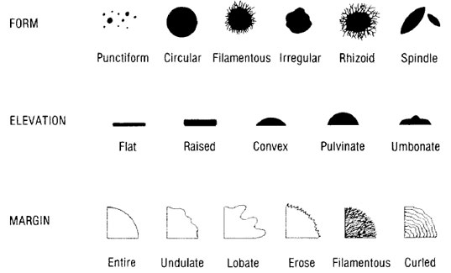

**Figure 2.1:** Bacterial colony morphology descriptors.

**Protocol 2.1:** Observation of bacterial colony morphology.

1. Measure the diameter of a representative colony in millimetres.
2. Describe the pigmentation (distinguishing between pigmented colonies and those secreting diffusible pigments) and record in Table 2.1.
3. Describe the form, elevation, and margin of a representative colony (using the correct terminology as indicated in Figure 2.1). Also indicate whether the colonies are smooth (shiny glistening surface), rough (dull, bumpy, granular, or matte surface), or mucoid (slimy or gummy appearance) and record in Table 2.1.
4. Record the opacity of the colonies (transparent, translucent, or opaque) in Table 2.1.

**Table 2.1:** Macroscopic characteristics of the colonies of typical bacteria grown on nutrient agar.

|  |  |  |  |  |  |
| --- | --- | --- | --- | --- | --- |
| **Characteristic** | **Microorganism** | | | | |
|  | *Escherichia coli* | *Staphylococcus aureus* | *Bacillus cereus* | *Proteus* species | *Pseudomonas aeruginosa* |
| Size range (mm) |  |  |  |  |  |
| Shape |  |  |  |  |  |
| Colour |  |  |  |  |  |
| Odour |  |  |  |  |  |

1. ***Fungal colonies on solid media***

You are supplied with a culture of a yeast (unicellular fungus) and moulds (multicellular fungi) that has been grown on the surface of Sabouraud/dextrose agar plates for 72 hours at 25°C. Examine the colonies and record your descriptions in Table 1.2.

**Table 2.2:** Macroscopic characteristics of the colonies of fungi grown on nutrient agar.

|  |  |  |  |
| --- | --- | --- | --- |
| Characteristic | Microorganism | | |
|  | Saccharomyces cerevisiae | Penicillium notatum | *Aspergillus niger* |
| Size range (mm) |  |  |  |
| Shape |  |  |  |
| Colour |  |  |  |
| Odour |  |  |  |

**Identification of microorganisms by microscopic characterisation**

**TASK 2B: Observation of microscopic characteristics**

The individual cells of typical bacteria are very small. To be seen clearly, they must be fixed to a glass slide, stained, and then examined using a microscope fitted with an **oil-immersion** **lens** (x100) which is capable of producing an overall magnification of at least x1000. The most common staining technique employed in microbiology is the **Gram stain** since it allows visualisation of the test bacterium under a light microscope and it is a discriminatory stain (i.e. it contributes to the identification of a microorganism, particularly when the information provided is used in conjunction with the macroscopic characteristics).

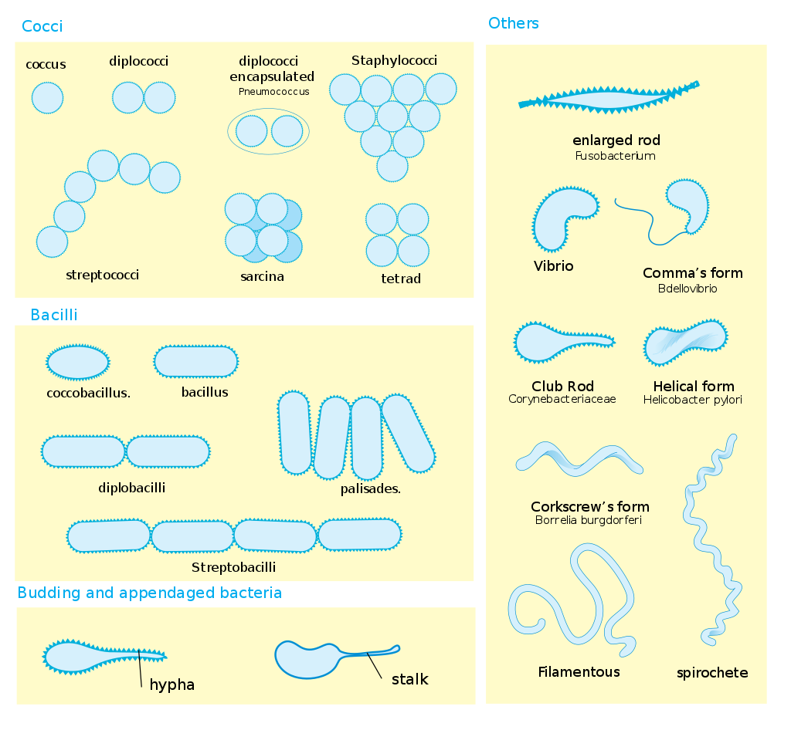

**Figure 2.2:** Bacterial cell shapes.

1. ***Gram stain of bacterial colonies isolated from solid media***

**Protocol 2.2:** Preparing Gram-stained bacterial cells.

**Please note, it is advisable that you wear safety gloves when handling staining reagents. However, gloves must be removed when working near the Bunsen burner.**

1. Hold a glass slide with metal forceps and flame thoroughly its **upper surface** using a Bunsen flame (this degreases the slide and allows even spreading of the film of bacterial cells). Allow the slide to cool.
2. Flame a loop until red hot and leave it to cool (hold steady, do not move around or lay it on the bench). Once cool, place a loopful of sterile water on the upper surface of the slide (use half the slide – step 3. tells you that you can fit two samples onto a slide). Flame the loop again and allow it to cool, then use it to pick up a speck of a bacterial colony (ideally this would be one bacterial colony). Mix this speck thoroughly into the drop of water to form a dilute milky suspension covering an area of about the size of a 20p coin (the aim is to provide a film that contains a single layer of cells. Too high a density of cells applied to the slide results in loss of detail as the cells are too closely packed together. The amount of culture necessary to produce a good film is learned from experience).
3. You can fit two samples onto a slide – repeat step 2 for a second culture, making sure that the two samples are well-separated. If labelling the samples on a slide using a permanent marker, use caution to ensure that the label is not destroyed during the ethanol wash.
4. Dry the film completely by warming the slide gently. Hold the slide well above the Bunsen flame.
5. Fix the film of cells to the slide by passing the **lower surface** of the slide through the Bunsen flame slowly twice. Allow the slide to cool.
6. Stain the film with 0.5% w/v crystal violet for 30 seconds.
7. Drain the crystal violet, rinse off the remainder with a solution of iodine (1% w/v iodinein 2% w/v potassium iodide). Cover the film with iodine for one minute.
8. Drain the iodine, rinse off the remainder with alcohol. Rock the alcohol from side to side until no more crystal violet is removed. This process should take no longer than 45 seconds.
9. Drain off the alcohol remaining and gently blot the slide dry.
10. Rinse with water.
11. Cover the film with 1% w/v safranin for 30 seconds. Wash the safranin off the slide with water and allow the slide to dry.

*Interpretation*

**Gram-positive** organisms are stained **blue/violet**.

**Gram-negative** organisms are stained **red/pink**.

Using the Gram-staining technique detailed above, prepare stained films of *E. coli, Staphylococcus aureus, Proteus* species, *Pseudomonas aeruginosa* and *Bacillus cereus*. Observe your slides under the microscope, using a low power objective lens (x10) first and then the **oil-immersion** **lens** (x100).

Indicate whether the organism is Gram-positive or Gram-negative and **make accurate drawings** of the cells of the five bacteria to show clearly the shapes of the individual cells, and the groupings of the individual cells (Table 2.3).

**Table 2.3:** Microscopic characteristics of bacterial colonies isolated from solid nutrient agar following application of Gram stain.

|  |  |  |
| --- | --- | --- |
| **Microorganism** | **Reaction to Gram stain** | **Sketch of cellular morphology and arrangement** |
| *Escherichia coli* |  |  |
| *Staphylococcus aureus* |  |  |
| *Proteus* species |  |  |
| *Bacillus cereus* |  |  |
| *Pseudomonas aeruginosa* |  |  |

1. ***Microscopic characteristics of fungi***

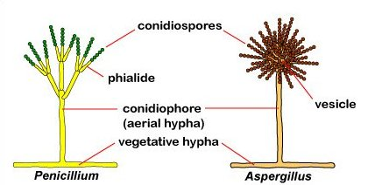

**Figure 2.3:** Structures of a typical mould.

Moulds are multicellular fungi. They are much larger than yeasts and they do not require the use of an oil-immersion lens to be seen clearly. The characteristics of their mycelia may be seen using the microscope’s low power objective lens (x10); the characteristics of their *hyphae*, *conidiophores* and spores may be seen using the high power lens (x40). Although no stains are required to visualise the sample, simple stains such as iodine solution or lactophenol cotton blue reagent are sometimes applied to highlight cellular morphology more clearly.

**Protocol 2.3:** Microscopic examination of fungi.

1. Place a drop of **iodine** solution on the surface of a glass slide.
2. Using a flamed and cooled loop, pick up a small amount of a colony of a fungus and tease it out in the drop of iodine.
3. Place a cover slip on top of the mounted material and examine the fungi using **first the low power (x10) and then the high power (x40) objective lenses** of the microscope. **Make accurate drawings** of the three fungi showing their *mycelia*, hyphal structure (whether septate or non-septate), *conidiophores* and spores (Table 2.4).

**Table 2.4:** Microscopic characteristics of fungi isolated from solid nutrient agar following addition to iodine solution.

|  |  |
| --- | --- |
| **Microorganism** | **Sketch of cellular morphology and arrangement** |
| *Penicillium notatum* |  |
| *Aspergillus niger* |  |
| *Saccharomyces cerevisiae* |  |

**Identification of microbes using selective and differential media**

Macroscopic observations of bacterial colony morphology can be useful in the identification of different species, as you saw in Task 2A. In addition to examining bacteria grown on nutrient agar, you will also find a wide range of differential and selective media used in clinical microbiology. These use the fact that different bacterial species have characteristic physiological and biochemical characteristics that can help to identify them. **Selective media** allow the growth of some bacteria, but not others. **Differential media** exploit specific chemical products of metabolism to produce visual indications of their production (e.g. by changes in colour of the colony or growth media), which can then be used to help identify the producing organism. Some media may be both selective and differential; and, in some cases, you may need to use multiple selective/differential media in combination to correctly identify an unknown organism.

**CASE STUDY 1: *Strep throat?***

Patient history: young child with a sore throat, mild fever, swollen lymph nodes, no history of previous Strep throat.

The clinician suspects that the child may have a Group A Strep (*Streptococcus pyogenes*) infection. However, many sore throats are caused by viruses instead. Before starting the child on a course of antibiotics, the clinician takes a throat swab culture and sends it to the lab for analysis.

Gram staining and microscopic observation showed the presence of a Gram-positive coccus-shaped bacterium. Your task is to identify the bacterialspecies causing this infection (Task 2C).

**TASK 2C: Differential media - use of blood agar to differentiate bacteria based on their haemolytic activity**

Blood agar plates are a differential medium used to detect haemolytic activity in different microorganisms. They are also useful for the clinical microbiologist, as this medium is enriched with mammalian blood and thus supports the growth of many nutritionally **fastidious** organisms. Several pathogenic bacteria can produce a haemolysin capable of lysing red blood cells, and thus a zone of lysed cells appears around these bacteria when they are grown on blood agar plates. This diagnostic test is particularly useful for the identification of *Streptococcal* sp.

There are three types of haemolysis as illustrated in Figure 2.4. **Beta haemolysis** is complete haemolysis: the blood cells are lysed and a clear zone forms around the colony. In **alpha haemolysis** (sometimes called incomplete haemolysis), the blood cells are not actually lysed; instead, the haemoglobin is reduced to methaemoglobin, causing a greenish or brownish discoloration. **Gamma haemolysis** is the lack of haemolysis, with no change to the surrounding medium after bacterial growth. Note that some bacteria may produce more than one more haemolysin, and also some haemolysins are oxygen-sensitive and only function in anaerobic conditions).

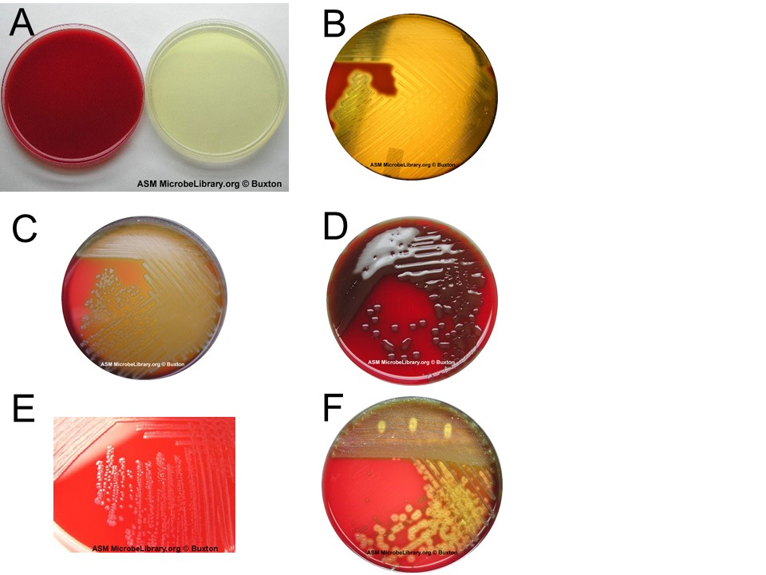

**Figure 2.4:** Analysis of haemolysis on blood agar. (A) Blood agar plates made by the addition of sheep’s blood (left) and Triptic Soy Agar plates (right). (B) *Streptococcus pyogenes* shows beta haemolysis.  
(C) Alpha haemolysis shown by *Streptococcus* species "Viridans group" streptococci. (D) Alpha haemolysis shown by an encapsulated strain of *Streptococcus pneumonia*. (E) Gamma haemolysis shown by growth of *Enterococcus faecalis* - many strains are usually non-haemolytic after 24 hours of incubation, but eventually display weak alpha haemolysis after prolonged incubation. (F) Mixed culture of normal upper respiratory flora and a beta-haemolytic *Streptococcus* sp. (indicating the possibility of a *S. pyogenes* infection).

You will be given an unknown *Streptococcus* sp.to identify based on its haemolytic activity, as well as a set of controls (strains with known alpha, beta, and gamma haemolytic activities).

**Protocol 2.4:** Streaking for single colonies.

1. Flame a loop, let it cool slightly and then touch it to the bacterial colony you have chosen to streak on a new plate.
2. Pick up the bottom of the new plate (leaving the lid on the bench) with your other hand, turn it over and gently streak the loop back and forth over a small area of the plate. Use light pressure so you don’t gouge the agar.
3. Return the plate to its lid so as to protect it from contaminants in the air while you re-flame the loop. Allow the loop to cool.
4. Pick up the plate again and touch the cooled loop onto an area of the agar that has not previously been streaked. (This step helps to quench the heat from the loop and so prevents it from killing any bacteria it subsequently comes into contact with.)
5. Drag the loop **once** through the previous streaked area and streak it out across a new area of agar. As the loop drags across the previous streak it will pick up some bacteria and distribute them across the new area of agar.
6. Repeat steps 4 - 5 two or three times as necessary to cover the entire surface of the plate (See Figure 2.5).

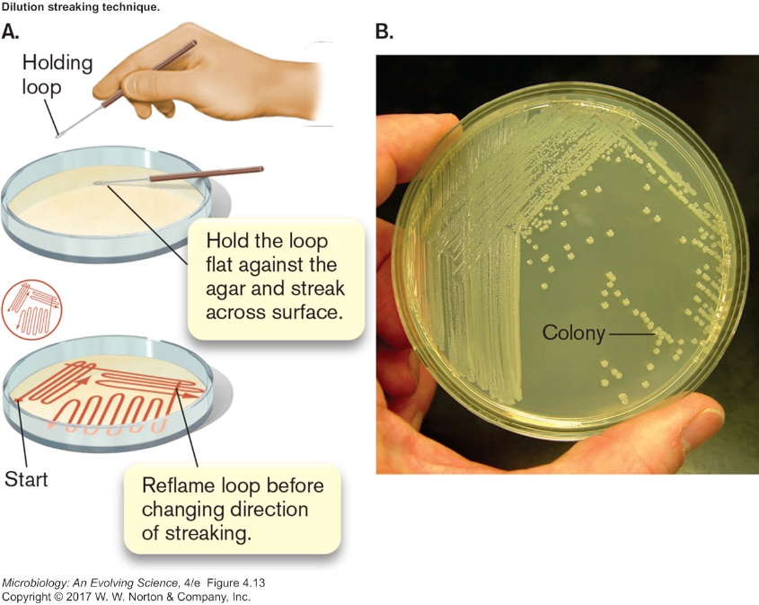

**Figure 2.5:** Streaking for single colonies.

1. Make sure that all agar plates are **clearly** labelled with your name, the sample name or number, your bench number, and the date. You should label the **bottom** of the plate (not the top – which may become separated from the bottom!). It is best to write in a circle around the edge of the plate, so that your writing will not obscure observation of the growth on the plate.
2. You will record your results in Table 2.4 during laboratory session 2 (Task 2D).

**BM327**

**Being a Biomolecular Scientist 3**

**Microbiology Laboratory Sessions**

**Semester 2**

**Laboratory 3**

**Pathogens of the intestinal tract**

**Laboratory 3: Pathogens of the intestinal tract**

**Aims**

* To understand how to identify unknown microorganisms affecting the intestinal tract using molecular and media-based techniques.

**Learning Outcomes**

At the end of this laboratory session, you should understand:

* How to identify pathogens of the intestinal tractusing differential and selective media.
* How to identify pathogens of the intestinal tract using and an API-20E set of biochemical tests.
* How to analyses and identify microbes through their ability to grow aerobically or anaerobically.

**Competencies**

* Using aseptic technique.
  + Pipetting.
  + Anaerobic cultivation of microbes.
  + Using appropriate methods to identify microorganisms (differential media, tests).
  + Documenting and reporting on experimental results and conclusions.

**Importance**

This laboratory session aligns with lectures and reinforces material relating to pathogens of the intestinal tract, bacterial identification and phylogeny, bacterial metabolism, epidemiology and clinical microbiology.

**Introduction**

There are many different techniques available to the clinical microbiologist who wishes to make a definitive identification of a potential pathogen. Many of these use the fact that different bacterial species have characteristic physiological and biochemical characteristics that can help to identify them.

In this laboratory session, you will be identifying pathogens of the intestinal tract(Case study 5) using differential and selective media (Task 3A), and an API-20E set of biochemical tests (Task 3B). In Case study 6, you will be looking at some of the enzymes involved in aerobic metabolism using biochemical assays (Task 3C), and at the ability of microbes to grow aerobically or anaerobically (Task 3D).

**CASE STUDY 5: The case of the contaminated spinach**

The epidemiologists have linked a sudden outbreak of diaorrheal diseases to a particular batch of frozen spinach, but the aetiological agent has not yet been confirmed.

You are working as a microbiologist with the Food Standards Agency, which is looking into the case. You suspect that it may be one of the common culprits – *E. coli, Salmonella,* or *Shigella* – but you need to figure out which.

A small portion of the spinach was homogenized and plated out on non-selective nutrient agar, and isolated colonies then grown in pure culture.

Your task is to determine whether the isolated pathogen is *E. coli, Salmonella,* or *Shigella* using selective and differential media (Task 3A) and an API-20E strip test (Task 3B).

Pathogenic enterobacteriaceae like *Salmonella, Shigella,* and *E. coli* are all relatively closely related, and they share a number of common characteristics – they are Gram-negative rods, non-spore-forming, facultative aerobes. However, they can be distinguished from one another by molecular methods or based on a number of biochemical tests, as can be seen in Table 3.1.

**Table 3.1:** Typical characteristics of *Escherichia coli, Shigella dysenteriae* and *Salmonella typhimurium*

|  |  |  |  |  |  |  |  |  |  |  |  |  |  |  |  |
| --- | --- | --- | --- | --- | --- | --- | --- | --- | --- | --- | --- | --- | --- | --- | --- |
| **Organism** | **Gram stain** | **Fermentation** | | | **H2S production** | **NO3 reduction** | **Indole production** | **VP reaction** | **Citrate use** | **Urease activity** | **Catalase activity** | **Oxidase activity** | **Gelatin liquefaction** | **Starch hydrolysis** | **Lipid hydrolysis** |
| **Lactose** | **Dextrose** | **Sucrose** |
| *Escherichia coli* | -  Rod | AG | AG | A ± | - | + | + | - | - | - | + | - | - | - | - |
| *Shigella dysenteriae* | -  Rod | - | A | A ± | - | + | ± | - | - | - | + | - | - | - | - |
| *Salmonella typhimurium* | -  Rod | - | AG ± | A ± | + | + | - | - | + | - | + | - | - | - | - |

Note: A = acid; AG = acid and gas; ± = variable reaction

**TASK 3A: Using selective and differential media for the cultivation and identification of *Escherichia, Salmonella,* and *Shigella* sp.**

***MacConkey agar***

MacConkey agar is a selective differential medium that is used for primary isolation of *Enterobacteriaceae* and related enteric Gram-negative bacilli and to aid in the identification of potentially pathogenic microorganisms. Its composition is listed in Table 3.2.

MacConkey agar is differential as it contains a sugar and the pH indicator neutral red, which can help to distinguish between bacteria which are able to metabolise the sugar, and those which cannot. It is often supplemented with lactose, but can also be supplemented with other sugars, such as sorbitol. Fermentation of the sugar produces acid, causing precipitation of the bile salts present in the medium and a change in colour due to the pH indicator. Bacteria that are not able to ferment the sugars will instead utilise the amino acids present in the medium, producing ammonia and causing the pH to increase.

**Table 3.2:** Composition of MacConkey/lactose agar

|  |  |
| --- | --- |
| **Component** | **Function** |
| Peptone | Nutrient source of carbon and nitrogen |
| Polypeptone | Nutrient source of carbon and nitrogen |
| Lactose | Carbohydrate nutrient |
| Bile salts | Inhibitor of Gram-positive bacteria and some fastidious Gram-negative bacteria |
| Sodium chloride | Osmolarity adjuster |
| Agar | Solidification agent |
| Neutral red | pH indicator |
| Crystal violet | Inhibitor of Gram-positive bacteria and some fastidious Gram-negative bacteria |
| Distilled water | Water source |

Therefore, following culture on MacConkey/lactose medium, strong lactose fermenters such as *Escherichia* species will produce red colonies with a surrounding zone of precipitated bile sometimes observable. The red colour is due to the indicator changing colour in response to acid production following lactose fermentation.

Slow or weak lactose fermenters such as *Citrobacter* and *Serratia* species may appear colourless after 24 hours or slightly pink after 24 - 48 hours.

Non-lactose fermenting microorganisms such as *Proteus*, *Salmonella* and *Shigella* species, with rare exceptions produce colourless or clear transparent colonies.

**Protocol 3.1:**

1. Using a flamed loop, take a colony from the agar plate provided containing your unknown clinical specimen.
2. Use this to streak a MacConkey agar plate (see protocol 1.4 for a more detailed explanation if necessary).
3. Repeat this exercise on fresh MacConkey agar plates for the **positive** and **negative** controls (*Escherichia* and *Salmonella*).
4. You will record your results in Table 4.1 in laboratory session 4, Task 4B.

**TASK 3B: Using an API-20E test for the identification of *Escherichia, Salmonella,* and *Shigella* sp.**

This diagnostic test uses 21 miniaturised biochemical tests and a database to identify an unknown microorganism that is suspected of being a member of the Enterobacteriaceae (i.e. Gram negative rods). Tests are grouped together in units of three and individual tests have a value of 1, 2 or 4 associated with them. By adding the values corresponding to positive reactions within each group, a 7-digit code ([Analytical Profile Index](http://en.wikipedia.org/wiki/Analytical_Profile_Index)) is generated that should reference a specific microorganism in the manufacturer’s database. The database also gives an indication of the confidence of the result.

Because of the long time between two laboratory sessions in this course (2 weeks), we are unable to perform the API-20E test (instead, this experiment has been performed for you and the results posted on MyPlace.

Protocol 3.2: Setting up an API-20E strip test.

1. Working in groups, place a small amount of water in the incubation tray (under the API strip itself) to provide humidity during incubation.
2. Prepare a milky (visibly turbid) suspension of your organism in sterile water.
3. Use a plastic sterile pipette to half-fill test wells of your API strip with the above suspension (Holding the strip at a slight angle as well as letting the end of the pipette touch the side of a well will make this easier. Make sure all air bubbles are eliminated).
4. When there is a line under a well (ADH, LDC, ODC, H2S, URE), add sterile mineral oil to completely fill in the well.
5. When there is a box under a well (CIT, VP and GEL), add some more bacterial suspension to completely fill in the well.
6. Place the plastic lid back on and label the tray with your name, date and organism code.
7. Incubate at 37°C for 24 hours.

*Interpretation of API 20E*

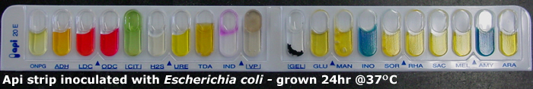

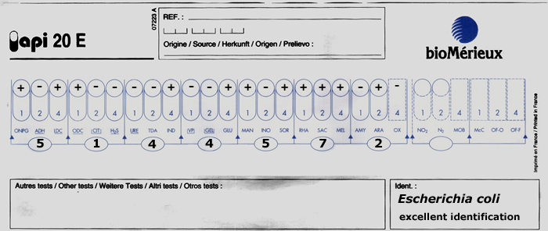

**Figure 5.1:** An API 20E test strip (top) and an API 20E score sheet (bottom).

Protocol 5.3: Completing the API 20E strip assay.

1. Add one drop of reagent TDA (10% ferric chloride) to the well labelled as TDA.
2. Add one drop of reagent IND (Kovacs’ reagent) to the well labelled as IND.
3. Add one drop of reagent VP1 (40% KOH), THEN add one drop of reagent VP2 (6% alpha-naphtol) to the well labelled as VP.
4. Wait for 10 min to observe colour changes.
5. Read the colour reactions obtained for each well, and record your results (as positive or negative) on the provided slip.
6. Give either 1, 2, or 4 points for positive reactions, 0 points for a negative reaction. Three test reactions are added together at a time to give your 7-digit API number which can be looked up in the codebook.
7. You will be given an API 20E score sheet. Stick this into your laboratory notebook and use it to generate a profile number for the unknown culture. Look up the profile number in the API 20E index book to identify the organism. Record your results in Table 5.2.

Table 5.2: Results of the API 20E strip test.

|  |  |  |
| --- | --- | --- |
| ***Your unknown #*** | **API Profile Number** | **Identification** |
|  |  |  |

What can you conclude about your unknown based on this result?

**CASE STUDY 6. The case of the careless clinician.**

You are working in a clinical microbiology with a friend, who has just left for holiday – leaving you to record the results from the last sample he was processing. You think he said that it was *C. diff*– or maybe *E. coli* – he was working on faecal samples earlier that morning. But you aren’t entirely sure and he isn’t answering his phone. (You need to get better friends.)

The patient can’t wait for a diagnosis until your friend gets back from his holiday, so you’d better figure it out for him. Your task is to determine whether the isolated pathogen is *Clostridium* or *E. coli* using biochemical assays (Task 4C) and by testing whether the pathogen is an obligate or facultative anaerobe (Task 4D).

**Anaerobic conditions:** A number of clinically relevant pathogens are **obligate** anaerobes and therefore must be cultivated anaerobically. In this laboratory, you will learn techniques for the anaerobic growth of microorganisms and perform biochemical assays to test for the presence of enzymes involved in aerobic growth. These complementary assays will help you to determine whether this clinical specimen is an anaerobe or an aerobe, and therefore aid in species identification.

**TASK 3C: Biochemical assays to identify pathogens of the intestinal tract**

*Test 1: Catalase test*

Catalase is an enzyme that breaks down hydrogen peroxide into oxygen and water. The enzyme is a haem protein expressed by most aerobic and facultatively anaerobic bacteria (excluding *Streptococci* species) and used to degrade any hydrogen peroxide that is generated during aerobic carbohydrate metabolism.

Protocol 4.3: Testing for catalase activity.

1. With a flamed loop, that has been allowed to cool, transfer cells from the centre of an isolated colony onto the surface of a glass slide.
2. Add 1 or 2 drops of 3% hydrogen peroxide to the cells.
3. Observe the slide and record your results.
4. Repeat the assay for your other samples. You should assay your positive and negative controls as well as your unknown microbe.

**Table 3.3:** Catalase activity assay results

|  |  |
| --- | --- |
| **Microorganism** | **Catalase test result –**  **carefully record what you observe** |
| Positive control  (*Escherichia coli*) |  |
| Negative control  (*Streptococcus* sp.) |  |
| Your unknown |  |

*Interpretation*

Rapid appearance and sustained production of gas (oxygen) bubbles is indicative of a positive test. A few tiny bubbles after 20 – 30 seconds are not considered positive.

*Test 2: Oxidase test*

Cytochrome oxidase is a haemprotein enzyme that is involved in the terminal chain of aerobic respiration by transferring electrons (hydrogen) to oxygen, to form water. It is possessed by aerobic and facultative anaerobic microorganisms. The test is helpful in screening Enterobacteriaceae (all negative), *Pseudomonas* (positive) or *Neisseria* (positive) species. The oxidase test uses a dye that can substitute for oxygen as an electron acceptor. In the reduced state the dye is colourless. However, in the presence of cytochrome oxidase and atmospheric oxygen it becomes oxidized and converts to a coloured derivative.

Protocol 3.4: Testing for oxidase activity.

1. Apply the oxidase strip onto an isolated colony.
2. Record any colour changes.
3. Repeat the assay for your other samples. You should assay your positive and negative controls as well as your unknown microbe.

**Table 3.4:** Oxidase activity assay results.

|  |  |
| --- | --- |
| **Microorganism** | **Oxidase test result –**  **carefully record what you observe** |
| Positive control  (*Pseudomonas aeruginosa)* |  |
| Negative control  (*Escherichia coli*) |  |
| Your unknown |  |

*Interpretation*

If the test microorganism is oxidase-positive, then an intense deep blue colour will develop within seconds.

**Table 3.5:** Catalase test and oxidase test observations and results

|  |  |  |
| --- | --- | --- |
| **Biochemical test** | **Observation** | **Positive or negative?** |
| Catalase production |  |  |
| Oxidase production |  |  |

What can you conclude about your unknown organism?

TASK 3D: Determining whether the unknown microorganism requires oxygen for growth

There are a number of different techniques used in microbiology laboratories for achieving anaerobic conditions to permit the growth of different microbes. In this lab, you will use two different techniques: use of thioglycollate medium and use of an anaerobic jar.

***Thioglycollate medium***

This medium contains a reducing agent, sodium thioglycollate, that binds to and consumes O2 and thus maintains a low oxygen tension in the medium. The medium also contains a redox indicator, resazurin, which turns pink in an oxidized environment. It is essential to use **fresh** thioglycollate medium (as indicated by the absence of pink colour). Growth of organisms in thioglycollate medium will depend on their oxygen requirements, as illustrated in Figure 3.1.

**Table 3.6:** Composition of fluid thioglycollate medium

|  |  |
| --- | --- |
| **Component** | **Function** |
| Tryptone | Nutrient source of carbon and nitrogen |
| L-Cystine | Nutrient source of carbon and nitrogen |
| Glucose | Carbohydrate nutrient |
| Yeast extract | Nutrient source/growth enhancer |
| Sodium chloride | Osmolarity adjuster |
| Agar | A small amount of agar is added to impede O2 diffusion into the medium |
| Sodium thioglycollate | Reducing agent that removes molecular O2 from the medium |
| Resazurin | Redox indicator that is colourless when reduced and turns pink when oxidized |
| Distilled water | Water source |

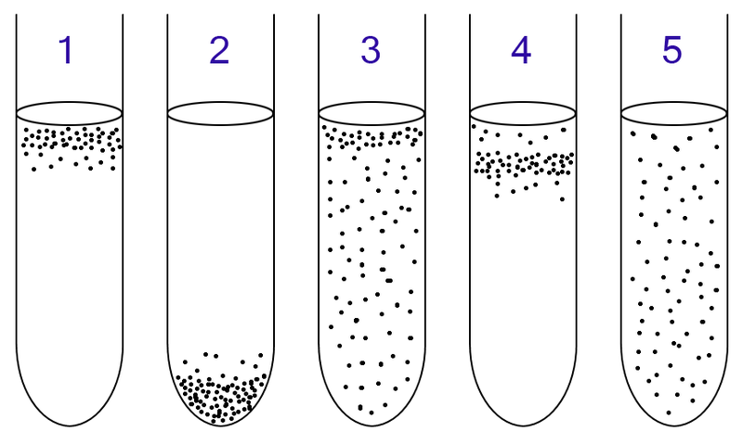

**Figure 3.1:** Growth of microorganisms with different oxygen requirements. (1) Aerobic organisms will grow at the surface, where the [O2] is highest. (2) Obligate anaerobes will grow at the bottom of the culture tube, where the [O2] is lowest. (3) Facultative anaerobes will grow throughout the tube, but exhibit more growth near the top (because they preferentially use aerobic respiration, which generates more ATP than anaerobic respiration or fermentation). (4) Microaerophiles grow near the surface, as they require O2 for growth (they cannot grow anaerobically), but are inhibited by high [O2]. (5) Aerotolerant organisms grow throughout the tube: they do not use O2 as an electron acceptor, but produce catalase and/or other enzymes for the detoxification of reactive oxygen species and are therefore not killed in the presence of O2.

Protocol 3.5: Anaerobic growth of microorganisms using fluid thioglycollate medium.

1. Label the culture tube with your name, today’s date, and the name of the inoculum.
2. Flame your inoculating loop. It is important to sterilize the entire platinum wire.
3. Lift the lid of the Petri dish slightly.
4. Cool the loop on an empty area of agar. (If it is too hot, you will kill the bacteria in the colony you choose.)
5. Gently pick up a single colony with the loop.
6. Close the lid of the Petri dish.
7. Using good aseptic technique, open the culture tube containing thioglycollate medium.
8. Put your loop into the broth and shake it gently. Be sure to innoculate the depths of the culture media.
9. Close the culture tube. Flame your loop before setting it down.
10. Repeat the procedure for each sample; you should inoculate your controls (*E. coli* and *Clostridium*)as well as your unknown organism into thioglycollate medium. Incubate the cultures at 37°C overnight.

11. You will record your results in Table 5.3 in laboratory session 4 (Task 5C).

*The GasPak/Anaerobic jar technique*

This system uses a sealed jar and a GasPak, which generates carbon dioxide and hydrogen; a palladium catalyst in the jar combines the hydrogen with oxygen (generating water); this then creates an anaerobic atmosphere in the jar, as shown in Figure 3.2. An indicator strip is used to verify that anaerobic conditions have been established: it contains methylene blue, which becomes colourless in the absence of oxygen.

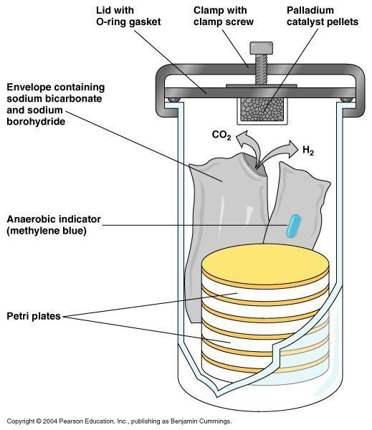

Figure 3.2: Anaerobic jar and Gas-Pak system

You will streak two agar plates; one will be incubated aerobically; the other, anaerobically. Each plate should be divided in half (use a marker-pen to draw a line on the base of the plate). You will inoculate one half of each plate with your unknown organism and one half with *Clostridium* as a control. As *Clostridium* will only grow anaerobically, its growth in this experiment will confirm that anaerobic conditions were achieved in the jar with the Gas-Pak.

Protocol 3.6: Anaerobic growth of microorganisms using the Gas-Pak system.

1. Label the base of the agar plate with your group name, today’s date, and label each plate +O2 or -O2 as appropriate.
2. Using a flamed loop and proper aseptic technique, take a colony from the agar plate provided containing your unknown clinical specimen.
3. Use this to streak for single colonies on half of each of your two stiff blood agar plates.
4. Repeat steps 2 - 3 for your control (*Clostridium*).
5. Keep one plate on your bench for incubation +O2 at 31°C for 48 - 72 hours. Deposit the other plate in the anaerobic jar for incubation -O2 at 31°C for 48 - 72 hours.
6. You will record your results Table 5.4 in laboratory session 4 (Task 5C).

**TASK 3E: Analysing blood agar plates (from Task 1C)**

Observe your blood agar plates from Task 1C within the first laboratory session. You should hold the plate up to the light to best observe any haemolysis (with transmitted light coming through the plate). Record the results in Table 2.4 below.

**Table 2.4:** Observation of haemolysis on blood agar plates.

|  |  |
| --- | --- |
| **Microorganism** | **Colony morphology and haemolysis – carefully record what you observe** |
| Alpha-haemolytic strain |  |
| Beta-haemolytic strain |  |
| Gamma-haemolytic strain |  |
| Your unknown |  |

What conclusions can you make?

What further experiments could you perform to definitively identify the pathogen?

What further experiments could you perform that would enable you to recommend a clinical treatment?

**TASK 3F: Staphylococcus aureus inoculation on mannitol salt agar**

Mannitol salt agar (MSA) is a selective differential medium that is used for primary isolation and identification of potentially pathogenic *Staphylococcus* *aureus* from non-pathogenic commensal microorganisms from the genus *Micrococcus*. MSA contains a relatively high sodium chloride content of 7.5% w/v which allows selection for microorganisms that can tolerate this level of sodium chloride. This makes the test selective. In addition, it contains mannitol and an indicator, phenol red. If a microorganism can ferment the mannitol, acid will be produced and the indicator will turn from red to yellow in response to the pH drop. This makes the test differential.

*Staphylococcus aureus* grows on MSA and ferments mannitol, turning the plate yellow. Microorganisms such as *Staphylococcus epidermis* although capable of growth on MSA, do not ferment mannitol. Members of the genus *Micrococcus* (e.g. *Micrococcus luteus*) cannot grow on MSA.

#### Protocol 3.7: Inoculation of your commensal flora on MSA agar.

* 1. Moisten a sterile swab until it is damp with the sterile water provided.
  2. Carefully insert the swab **high** into one of your nostrils and gently rub its interior surfaces.
  3. Smear the swab onto about one quarter of a MSA plate supplemented with oxacillin, rolling the swab around to ensure transfer of inoculum onto plate. Repeat and smear a second swab to a MSA plate without supplement.
  4. Place the used swab into the clinical waste disposal bags at the end of the bench.
  5. Take a new sterile loop and streak (using a flamed loop) the remainder of the plate with the initial inoculum.
  6. Label the base of your plate with name and date.
  7. Place in storage container for incubation at 31°C for 48 - 72 hours.

You will record your results in Table 3.2 in laboratory session 3 (Task 3A).

**BM327**

**Being a Biomolecular Scientist 3**

**Microbiology Laboratory Sessions**

**Semester 2**

**Laboratory 4**

**Pathogens of the circulatory system and skin**

**Laboratory 4: Pathogens of the circulatory system and skin**

**Aims**

* To understand how to identify unknown microorganisms using molecular and media-based techniques.
* To understand how to isolate and analyse plasmid DNA from microorganisms.
* To understand how to carry out PCR and interpret the results from multiplexed reactions.

**Learning Outcomes**

At the end of this laboratory session, you should understand:

* How to use differential media to identify microorganisms.
* How to use MVLA typing to identify microorganisms.
* How to use PCR to identify microorganisms.

**Competencies**

* Using aseptic technique.
* Pipetting.
* Using appropriate methods to identify microorganisms (differential media, tests, MVLA typing).
* Using PCR to discriminate between bacterial species.
* Documenting and reporting on experimental results and conclusions.

**Importance**

This laboratory session aligns with lectures and reinforces material relating to circulatory system and skin pathogens, bacterial identification and phylogeny, bacterial virulence and clinical microbiology.

**Introduction**

There are many different techniques available to the clinical microbiologist who wishes to make a definitive identification of a potential pathogen. Many of these use the fact that different bacterial species have characteristic physiological and biochemical characteristics that can help to identify them. In this laboratory session, you will be identifying a pathogen of the skin and circulatory system, *Staphylococcus aureus,* using differential media (Task 4A), biochemical assays (Tasks 4B and 4C), and a PCR-based technique called MVLA typing (Task 4D).

*Staphylococcus aureus* and *Staphylococcus epidermidis* are both members of the normal human skin flora (commensals), and dangerous pathogens often associated with nosocomial infections. Although *Staphylococcus aureus* and *Staphylococcus epidermidis* appear very similar when examined under the microscope (as in the Gram-staining procedure you carried out in laboratory session 1), they can be distinguished from one another on the basis of several different phenotypic characteristics (Table 4.1).

Table 4.1: Typical characteristics of *Staphylococcus aureus*, *Staphylococcus epidermidis*, and micrococci

| Characteristic | *S*. *aureus* | *S*. *epidermidis* | Micrococci |
| --- | --- | --- | --- |
| Catalase activity | + | + | + |
| Coagulase production | + | - | - |
| Thermostable nuclease production | + | - | - |
| Lysostaphin sensitivity | + | + | - |
| Anaerobic utilization of glucose | + | + | - |
| Anaerobic utilization of mannitol | + | - | - |
| ‘+’ = Most (90% or more) strains are positive  ‘-‘ = Most (90% or more) strains are negative | | | |

**CASE STUDY 4: Epidemiology of an MRSA outbreak**

A number of patients at the local hospital have been acquiring secondaryinfections after seeing Dr. X for routine medical procedures. However, many of the patients also move in the same social circles, and so it is not clear whether these infections are nosocomial or community-acquired.

As a consulting microbiologist from the NHS, you have been asked to help the hospital discover the source of the pathogens, so that they can clean up their protocols for infection control if necessary. The first step is to determine whether the bacteria isolated from the patients are all genetically identical (from the same source) or different (from different sources).

You will use selective and differential media to analyse your own commensal flora (results from laboratory session 2, Task 3E) and the unknown and control strains from the MRSA epidemic (Task 3A).

Your task is to identify the strains involved in the outbreak. You suspect that it is MRSA, but you must first confirm this. You will first determine whether the patient isolates are in fact *Staphylococci* using a **lysostaphin** test (Task 3B); you will then determine whether they are *Staphylococcus aureus* or other *Staphylococci* using a diagnostic **coagulase** test (Task 3C). Finally, you will identify a *Staphylococcus aureus* isolate using MVLA typing (Task 3D).

**TASK 4A: Microbial colonies on MSA plates (from Task 2E)**

You will analyse the growth and colony morphology of the unknown pathogen on MSA agar, and also the growth and colony morphology of your own nasal flora (from the plates you inoculated in laboratory session 2, Task 2E). You have also been provided with cultures of type strains of *Staphylococcus aureus* and *Staphylococcus epidermidis* grown on MSA agar as controls. Record your observations in Table 4.2.

**Table 4.2:** *Staphylococci* strains grown on MSA plates

|  |  |  |  |
| --- | --- | --- | --- |
| **Isolate** | **Growth on MSA agar?** | **Growth on MSA**  **+ oxacillin agar?** | **Characteristics of colonies** |
| *Staphylococcus aureus*  (control) |  |  |  |
| *Staphylococcus epidermidis* (control) |  |  |  |
| Your unknown culture  (# ______) |  |  |  |
| Your commensal flora  (from Task 2E) |  |  |  |

What can you conclude about your unknown?

What can you conclude about your own skin microbiome?

**TASK 4B: Assaying for lysostaphin sensitivity**

Another diagnostic characteristic of *Staphylococci* sp. is their sensitivity to lysostaphin, an enzyme that cleaves the pentaglycine bridge present in the peptidoglycan cell wall of these microorganisms. (Other Gram-positive bacteria like *Micrococcus* sp. lack this pentaglycine bridge and are therefore resistant to lysostaphin.)

Protocol 4.1: Lysostaphin sensitivity test.

1. Use a sterilised inoculating loop to transfer an isolated colony from agar plate to a tube containing 0.2 ml phosphate-saline buffer, and emulsify the colony in the buffer until the cells are well-suspended.
2. Transfer half of the suspended cells to another tube and mix with 0.1 ml phosphate-saline buffer (this will be your control reaction).
3. Add 0.1 ml lysostaphin (dissolved in 0.02 M phosphate-saline buffer containing 1% NaCl) to original tube for concentration of 25 µg lysostaphin/ml.
4. Incubate both tubes at 37°C for not more than two hours.

*Interpretation*

A positive reaction is detected by clearing of bacterial turbidity (cell lysis).

The test is considered negative if clearing has not occurred after 2 hours.

TASK 4C: Assaying for coagulase activity

Coagulase is an enzyme that has prothrombin-like activity and is capable of converting plasma fibrinogen to fibrin with resultant clot formation. Coagulase can be present in two forms, “free” and “bound” each having different properties and requiring different testing procedures. In this laboratory we will use the more rapid test for bound coagulase, the so-called slide test. As not all strains of *Staphylococcus aureus* express bound coagulase a negative test result requires the free coagulase (tube) test to be performed for absolute confirmation.

Protocol 4.2: Coagulase slide test.

1. Place a drop of sterile water on a glass slide.
2. Using a flamed loop, that has been allowed to cool, remove an isolated colony from the culture plate and gently emulsify on the slide with the drop of sterile water.
3. Place a drop of plasma immediately adjacent to the bacterial suspension and mix the two samples together.
4. Gently tilt the slide back and forwards, observing for the immediate formation of a white precipitate.

*Interpretation*

A positive reaction (formation of white precipitate) is typically detected 15 – 20 seconds. The test is considered negative if clumping is not observed within 2 – 3 minutes.

**Table 4.3:** Coagulase activity of *Staphylococcus* sp.

|  |  |
| --- | --- |
| **Microorganism** | **Coagulase test result –**  **carefully record what you observe** |
| Positive control  (*Staphylococcus aureus*) |  |
| Negative control  (*Staphylococcus epidermidis*) |  |
| Your unknown |  |

**Table 4.4:** Characterization of your unknown organism

|  |  |  |
| --- | --- | --- |
| **Biochemical Test** | **Observation** | **Positive or Negative?** |
| Mannitol fermentation |  |  |
| Lysostaphin sensitivity |  |  |
| Coagulase activity |  |  |

What can you conclude about your unknown organism?

**TASK 4D: MLVA-typing *Staphylococcus aureus***

If the previous tests have allowed you to determine that your unknown is *Staphylococcus aureus*, you will now be able to determine its identity more preciselyusing a technique called MLVA (multiple locus variable number of tandem repeats analysis), which can discriminate between different strains of *Staphylococcus aureus* based on different numbers of variable tandem repeats in specific loci. You will amplify these loci using PCR, and determine the size of the PCR products using agarose gel electrophoresis. The size of the locus (PCR product) reflects the number of repeats present in your strain. If more repeats are present, the PCR product will be larger (see Figure 4.1). If your unknown was not *Staphylococcus aureus*, you will still be able to perform the MLVA analysis – use the *Staphylococcus aureus* culture that was provided as a positive control for the previous experiments.

You will be analysing five different loci in total; one in a single PCR reaction (the *spa* gene) in **Protocol 4.3**, and four in a multiplexed PCR reaction (the *clfA, cflB, sdr,* and *ssp* genes) as detailed in **Protocol 4.4**.

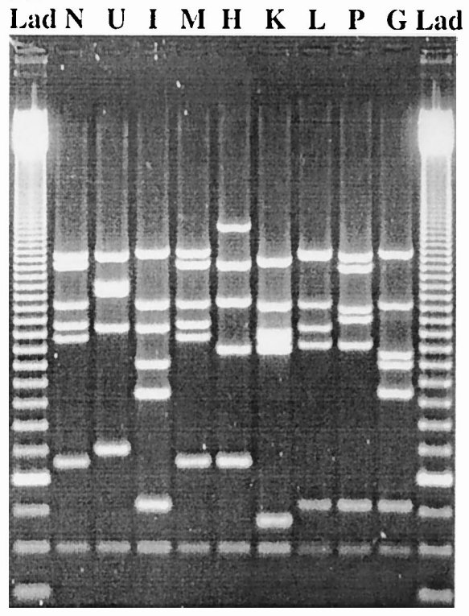

**Figure 4.1:** MLVA patterns of isolates 18 to 34 [taken from Sabat *et al.* (2003). J Clin Microbiol. **41:** 1801 – 1804].

**Table 4.5:** Primers used in this experiment

(Sabat A *et al*., J Clin Microbiol. 2003 41: 1801)

|  |  |  |  |
| --- | --- | --- | --- |
| **Gene/locus** | **Primer name** | **Primer sequence (5’-3’)** | **Product size\*** |
| *clfA* | clfA-F | GATTCTGACCCAGGTTCAGA | 1183bp |
| clfA-R | CTGTATCTGGTAATGGTTCTTT |
| *clfB* | clfB-F | ATGGTGATTCAGCAGTAAATCC | 828bp |
| clfB-R | CATTATTTGGTGGTGTAACTCTT |
| *sdr* | sdr-F | GTAACAATTACGGATCATGATG | 670bp |
| sdr-R | TACCTGTTTCTGGTAATGCTTT |
| *spa* | spa-F | AGCACCAAAAGAGGAAGACAA | 284bp |
| spa-R | GTTTAACGACATGTACTCCGT |
| *ssp* | ssp-F | ATCMATTTYGCMAAYGATGACCA | 173bp |
| ssp-R | TTGTCTGAATTATTGTTATCGCC |

* Product size is estimated with reference genome N315. Other strains are expected to have different sizes.

***Setting up PCR reaction mixtures***

* Work on ice.
* Pipet carefully and accurately.
* Watch what you touch – you are covered with nucleases and your own *Staphylococcus aureus*!
* Stay organized – keep track of what you have added to your reaction and what still needs to be added.
* **Label your tubes** – there will be 96 on the thermocycler altogether!

**Protocol 4.3:** Set up single PCR (*spa* gene).

The *spa* gene must be amplified separately as these primers do not perform well in the multiplex PCR reaction. The single PCR mixture contains: primers for the gene to be amplified (the *spa* gene), the template DNA, the polymerase enzyme (*Taq*), dNTPs, the reaction buffer, and PCR-grade water.

**Table 4.6:** Reaction mixture for the *spa* single PCR

|  |  |
| --- | --- |
| **Component** | **Volume for 1 reaction** |
| 5X Taq buffer | 4 μl |
| PCR grade water | 13.75 μl |
| F primer | 1 μl |
| R primer | 1 μl |
| *Taq* polymerase | 0.25 μl |
| **Total volume** | **20 μl** |

1. Label your PCR tube carefully with the gene name (*spa*) and your bench number.
2. Use a white thin (10 μl) tip to pick one big isolated colony from the plate provided to you, and place this at the bottom of your PCR tube. Add 20 μl PCR master mix.
3. Keep the reaction mixture on ice until the whole class is ready to proceed to the amplification step (thermocycler).

**Protocol 4.4:** Set up multiplex PCR (*clfA, clfB, sdr* and *ssp* genes).

The multiplex PCR mixture contains: primers for each of the genes to be amplified (the *cflA, cflB, sdr,* and *ssp* genes), the template DNA, the polymerase enzyme (*Taq* polymerase), dNTPs, and the reaction buffer.

**Table 4.7:** Reaction mixture for the multiplex PCR

|  |  |
| --- | --- |
| **Component** | **Volume for 1 reaction** |
| PCR grade water | 7.75 μl |
| 5X Taq buffer | 4 μl |
| cflA-F primer | 1 μl |
| cflA-R primer | 1 μl |
| cflB-F primer | 1 μl |
| cflB-R primer | 1 μl |
| sdr-F primer | 1 μl |
| sdr-R primer | 1 μl |
| ssp-F primer | 1 μl |
| ssp-R primer | 1 μl |
| *Taq* polymerase | 0.25 μl |
| **Total volume** | **20 μl** |

1. Label your PCR tube carefully, including your bench number.
2. Use a white thin (10 μl) tip to pick one big isolated colony from the plate provided to you, and place this at the bottom of your PCR tube. Add 20 μl PCR master mix.
3. Keep the reaction mixture on ice until the whole class is ready to proceed to the amplification step.

***PCR amplification for both reactions***

Amplification of DNA fragments will be performed with an initial denaturation at 94°C for 10 minutes followed by 25 cycles of 30 seconds at 94°C, 30 seconds at 55°C, and one minute at 72°C, with a final extension at 72°C for 5 minutes on a Bio-Rad DNA-Engine thermocycler. This PCR programme takes about 2½ hours to run.

**Protocol 4.5:** Make an agarose gel.

* + - 1. Prepare a gel tray. Use tape to seal off the top and bottom ends. Insert the comb in the slots in the tray. **Check with a demonstrator before proceeding.**
      2. A 2% agarose solution has been made for you as follows: 2 g of agarose were added to a glass flask, and 100 ml 1X TAE buffer. The agarose solution was heated in a microwave till agarose is completely dissolved in the buffer, and then cooled down to about 50°C.
      3. Pour the agarose into your prepared gel tray and leave it to set.

***Gel electrophoresis***

After the thermocycler run has finished, your samples will be run on your gel for you as follows: we will add 5 µl of *spa* PCR product to the multiplex PCR products and then run 16 µl of the combined reaction on the 2% agarose gel. Bioline 100bp DNA ladder (BIO-33056) will be used for each of the gels. We will then take gel images with the “gel doc system” and post your data to the BM327 microbiology class sub-page.

**TASK 4E: Observing and recording results (from Task 4A)**

You will need to observe the growth of your unknown and control strains on selective/differential media and record your results in Table 4.8.

**Table 4.8:** Visual observation of microbial colonies incubated on MacConkey agar

|  |  |
| --- | --- |
| **Microorganism cultured** | **Visual observations (colony characteristics)** |
| *Escherichia coli* |  |
| *Salmonella enteritidis* |  |
| *Your unknown* |  |

What can you conclude about your unknown based on this result?

You will also need to observe the growth of your unknown and control strains in aerobic and anaerobic conditions and record your results in Table 5.3 and Table 5.4.

**Table 4.9:** Visual observation of microbial growth in fluid thioglycollate medium.

|  |  |  |
| --- | --- | --- |
| **Microorganism Cultured** | **Visual observations (turbidity/growth, colour)** | **Conclusions** |
| *Your unknown* |  |  |
| *Escherichia coli* |  |  |
| *Clostridium* |  |  |

**Table 4.10:** Visual observation of microbial growth on stiff blood agar plates incubated aerobically and anaerobically

|  |  |  |
| --- | --- | --- |
| **Microorganism cultured** | **Visual observations (colony characteristics) – plates cultured aerobically** | **Visual observations (colony characteristics) – plates cultured anaerobically** |
| *Your unknown* |  |  |
| *Clostridium* |  |  |

What can you conclude about your unknown based on this result?

**TASK 4F: Analysing antibiotic resistance of *P. aeruginosa* isolates**

Bacteria in biofilms tend to be more resistant to killing and/or growth inhibition by antimicrobial agents. A number of different mechanisms have been proposed to explain this increased resistance, including that the biofilms may provide a measure of physical protection, i.e. with an extracellular matrix shielding the cells from contact with the antimicrobial agent. Alternatively, the cells present in a biofilm may have altered their gene expression/physiological state such that they are now more resistant to the antimicrobial. In this lab, you will test your *Pseudomonas aeruginosa* isolates to determine whether they are sensitive or resistant to the aminoglycoside antibiotic gentamicin.

**Protocol 4.6**: **Determining the minimal inhibitory concentration of an antibiotic**

1. Prepare a seed lawn for each of your three *Pseudomonas aeruginosa* isolate as follows: pipette 100 µl of the supplied culture onto the centre of a Mueller Hinton agar plate and use a sterile plastic spreader to distribute the culture evenly over the surface of the agar. The liquid should be completely absorbed into the agar before you add the antibiotic disks in step 5.
2. Obtain an empty petri dish containing fifteen sterile filter discs.
3. In four sterile 1.5 ml tubes, prepare dilutions of the supplied solution of gentamicin (1 mg/ml). You will be adding 20 µl of each dilution to a filter disk, but it is always a good idea to prepare a slightly larger volume to account for any pipetting errors - e.g. prepare 25 µl for each filter disk. Prepare the dilutions so that you will end up with 4 µg, 8 µg, 12 µg and 16 µg of gentamicin when you add 20 µl of the dilution to a filter disk.

Equation: C1 x V1 = C2 x V2 [C, concentration; V, volume]

Example: 4 µg/20 µl x 25 µl = 1 mg/ml x ???

Using this equation, complete the following table and then prepare the dilutions:

Table 4.11: Calculation of antibiotic dilutions

|  |  |  |  |  |
| --- | --- | --- | --- | --- |
| **Final amount on disc** | **4 µg** | **8 µg** | **12 µg** | **16 µg** |
| **Volume stock solution** |  |  |  |  |
| **Volume H20** |  |  |  |  |

**BM327**

**Being a Biomolecular Scientist 3**

**Microbiology Laboratory Sessions**

**Semester 2**

**Laboratory 5**

**Pathogens of the Respiratory Tract**

**Laboratory 5: Respiratory tract pathogens**

**Aims**

* To understand how to identify unknown microorganisms using molecular and media-based techniques.

**Learning Outcomes**

At the end of this laboratory session, you should understand:

* How to characterise bacterial species from their ability to form biofilms.
* How to characterise bacteria species from their antibiotic resistance.
* How to identify a potential pathogen using differential staining.

**Competencies**

* Using aseptic technique.
* Performing calculations and preparing solutions.
* Pipetting.
* Using pure culture and selective techniques to enrich for, and isolate, microorganisms.
* Using appropriate methods to identify microorganisms (microscopy, media-based and molecular techniques).
* Documenting and reporting on experimental results and conclusions.

**Importance**

This laboratory session aligns with lectures and reinforces material relating to respiratory tract pathogens, bacterial metabolism, bacterial virulence, antibiotic resistance, bacterial identification and clinical microbiology.

**Introduction**

There are many different techniques available to the clinical microbiologist who wishes to make a definitive identification of a potential pathogen. Many of these use the fact that different bacterial species have characteristic physiological and biochemical characteristics that can help to identify them. In this laboratory session, you will be looking at some of the phenotypic properties of bacteria that can contribute to their virulence (Case study 2, Tasks 2A and 2B) and using a differential stain to identify a potential pathogen (Case study 3, Task 2C).

You will also finish the experiment you started in the last laboratory (Case study 1, Task 1C) in Task 2D this week. In Task 2E, you will use selective and differential media to isolate bacteria for laboratory session 3.

**CASE STUDY 2: Cystic fibrosis**

Cystic fibrosis is a genetic disorder (autosomal recessive) that mostly affects the lungs, with patients contracting infections due to mucus build-up, decreased mucocilliary clearance, and increased inflammation. *Staphylococcus aureus, Haemophilus influenzae,* and *Pseudomonas aeruginosa* commonly infect the lungs of CF patients. These are usually chronic, life-long infections, dominated by *Pseudomonas aeruginosa* in their later stages.

In this clinical study, we are interested in which factors make *Pseudomonas aeruginosa* a successful pathogen in the CF lung. You will characterise the *Pseudomonas* sp. isolated from several different patients: you will analyse their ability to form biofilms (Task 2A) and their resistance to antibiotics (Task 2B).

**TASK 5A: Analysing biofilm attachment of *P. aeruginosa* isolates**

Biofilm formation is a key virulence factor for many clinically important pathogens, and is also a particular problem in healthcare situations, where biofilms can form on medical devices and be difficult to eradicate. Bacteria in biofilms are often more resistant to killing by antibiotics. Biofilm formation is a complex, regulated process that begins with the initial attachment of bacteria to a surface, often mediated by flagella, pili, or other surface proteins on the bacterial cell. This surface attachment is what you will measure using a crystal violet stain that binds to the bacteria.

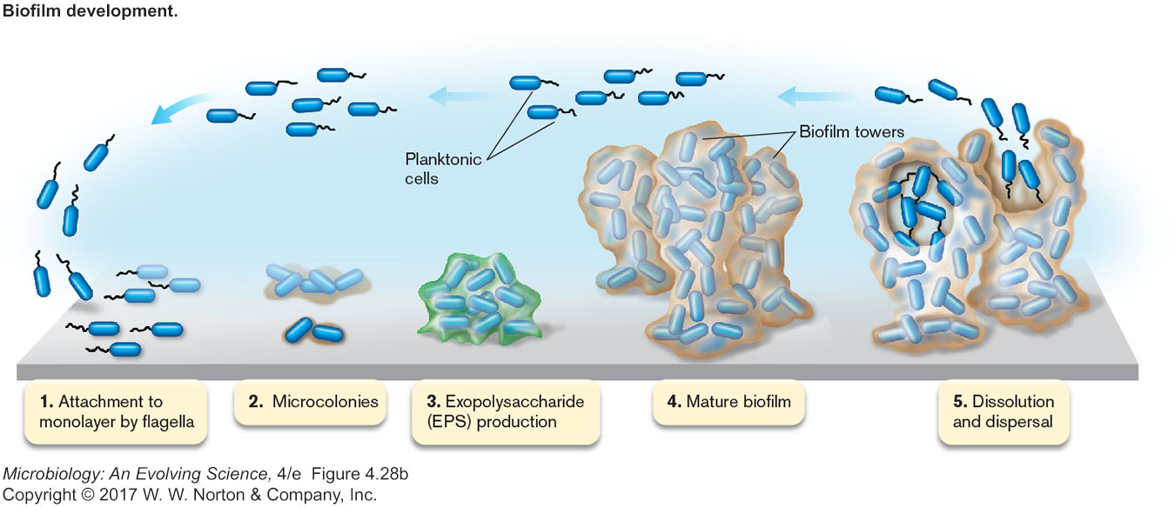

Figure 5.1: Biofilm formation by *Pseudomonas*.

You will be provided with a tube of medium, and three liquid cultures of *Pseudomonas* which have been grown overnight in that same medium. You will test whether these *Pseudomonas* sp. are able to form biofilms using a crystal violet assay (Protocol 5.1).

Crystal violet will stain the bacteria but not the plastic. Therefore, attachment will be observed by the presence of a purple ring (see Figure 5.2 below). This purple ring is made up of bacteria that have attached to the surface at the liquid-air interface.

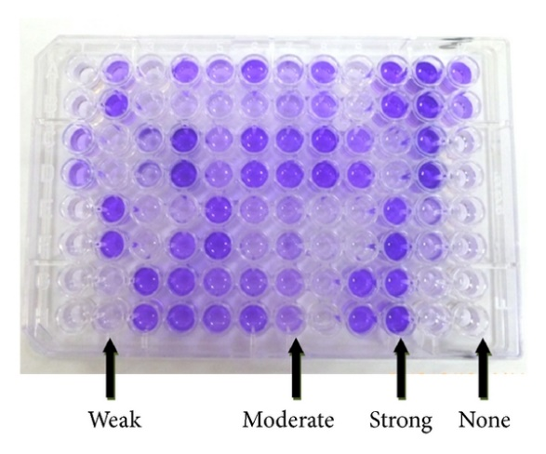

Figure 5.2: Biofilm formation measured using a crystal violet stain. Biofilm formation can be scored qualitatively e.g. +++: strong,  
++: moderate, +: weak, 0: no formation.

Protocol 5.1: Biofilm formation assay.

1. Pipette 100 µl of medium into well A1: this is your negative control. Pipette 100 µl into three separate wells for each of the three *Pseudomonas* cultures. This will ensure you have triplicate samples for each culture. As you will be sharing a 96-well plate, be sure to carefully record the location of each sample - i.e. culture 1, wells B1, B2 and B3 etc.
2. Incubate the cells at 30°C for 30 minutes.
3. Add 25 µl of 1% crystal violet solution to each well.
4. Incubate the plate for a further 15 minutes at room temperature.
5. After this time, rinse the wells thoroughly with water and invert the tray over some blue-roll paper to let the wells drain carefully.
6. Record your observations in Table 2.1 using the qualitative scores given above (+++, ++, +, 0).

Table 5.1: Biofilm formation (attachment of bacteria to the wells)

|  |  |  |  |
| --- | --- | --- | --- |
| *Pseudomonas* isolate (name/reference ID) | Repeat (triplicates of each isolate) | Location of wells in 96-well plate | Purple ring estimation |
|  | 1 |  |  |
| 2 |  |  |
| 3 |  |  |
|  | 1 |  |  |
| 2 |  |  |
| 3 |  |  |
|  | 1 |  |  |
| 2 |  |  |
| 3 |  |  |

**TASK 5B: Analysing antibiotic resistance assay (from Task 2B)**

You should carefully measure the diameter of each zone of inhibition in millimetres. Put your results in Table 5.2.

**Table 5.2:** Sensitivity of *Pseudomonas aeruginosa* isolates to gentamicin. Inhibition zone diameters should be measured in millimetres.

|  |  |  |  |  |  |
| --- | --- | --- | --- | --- | --- |
| **Isolate** | **Gentamicin** | | | | |
| **0 µg** | **4 µg** | **8 µg** | **12 µg** | **16 µg** |
| Culture _____ |  |  |  |  |  |
| Culture _____ |  |  |  |  |  |
| Culture _____ |  |  |  |  |  |

Refer back to Table 5.1, where you recorded the ability of each of these strains to form biofilms. Is there any correlation between gentamicin resistance and the ability of these strains to form biofilms?

Discuss the significance of your results.

**CASE STUDY 3. Tuberculosis?**

Patient history: fever, persistent cough, weight loss, loss of appetite. The patient is immunocompromised and has recently travelled extensively outside the UK.

The patient is positive for the Tb skin test, but has had the BCG vaccine and so this may be a false positive. The clinician suspects that it may in fact be an infection by *Mycobacterium tuberculosis,* and takes a sputum sample and sends it to the lab for analysis. The sample was plated on Löwenstein–Jensen medium and colonies were then isolated into pure culture.

Your task is to identify the bacterialspecies causing this infection (Task 2C).

**TASK 5C: Using differential stain to identify a respiratory tract pathogen**

Certain microorganisms, in particular mycobacteria, have the power to retain specific stains even when they are decolourised by mineral acids. They are therefore referred to as being “acid-fast”. The ability of mycobacteria to resist decolourisation is due to the presence of high amounts of mycolic acid within their cell wall structure. Therefore, you can use this stain to determine whether the infectious agent in this case is a mycobacterium or not. You should carry out the staining procedure on positive and negative controls (acid-fast and non-acid-fast bacteria) as well as on your unknown.

**Protocol 5.2:** Modified Ziehl-Neelson stain.

1. Hold a glass slide with metal forceps and flame thoroughly its operational **upper surface** using a Bunsen flame. Allow the slide to cool. Flame a loop until red hot and leave it to cool. Place a loopful of sterile water on the upper surface of the slide. Flame the loop again and allow it to cool, then use it to pick up a speck of a colony from the culture provided. Mix this speck thoroughly into the drop of water to form a dilute milky suspension covering an area of about the size of a 20p coin.
2. Allow the film to dry completely. You may need to do this by warming the slide gently, holding it in forceps well above the Bunsen’s flame.
3. Fix the film of cells to the slide by passing the lower surface of the slide through the Bunsen flame slowly twice. The slide will now be hot to the touch; allow it to cool.
4. Place the slide on the staining rack over the sink.
5. Cover the slide with **carbol fuchsin** solution (this contains phenol, so take care to avoid contact with skin. Wash hands immediately if this happens). Allow to stand for **5 min.**
6. Rinse with water.

***Take great care, wear protective gloves and safety spectacles now to handle the next solution (hydrochloric acid in ethanol) which is corrosive!***

1. Decolourise the slide by covering it with **hydrochloric acid in ethanol** solution, and allow to stand for 15 - 30 seconds.
2. Immediately remove excess acid by running slide in tap water.
3. Counterstain with **malachite green** solution for one minute.
4. Remove excess stain with water.
5. Gently blot dry and examine with the oil-immersion lens (x100).

**Table 2.3:** Results of the modified Ziehl-Neelson stain

|  |  |
| --- | --- |
| **Microorganism** | **Cellular morphology – carefully record what you observe under the microscope** |
| Positive control  (acid-fast bacterium) |  |
| Negative control (non-acid-fast bacterium) |  |
| Patient sample |  |

*Interpretation*

(Acid-fast bacilli appear red on a pale green background).

What conclusion(s) can you draw from this experiment?

What other tests might you do to identify this pathogen?

[Updated: 9th August 2024]